**Battery container simulation on Ansys**

**Made by Friedly WOLI**

* The link for the battery weight that I use [Battery Cells.xlsx](https://supaerotlse.sharepoint.com/:x:/r/sites/TLSeRacing2025-2026-Powertrain/_layouts/15/Doc2.aspx?action=edit&sourcedoc=%7B7e332883-10d3-4fe3-b192-13fe623bf0cc%7D&wdOrigin=TEAMS-WEB.teamsSdk_ns.rwc&wdExp=TEAMS-TREATMENT&wdhostclicktime=1768273901596&web=1) and I use 1 pa for the simulation

As fixed support I took this

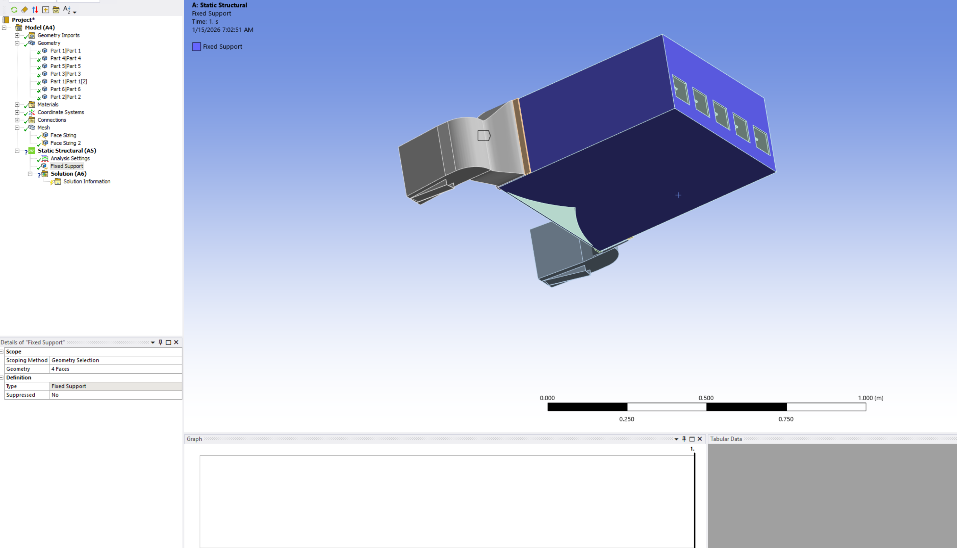Figure 2: the fixed surface that I consider

The force that I apply on the bottom surface

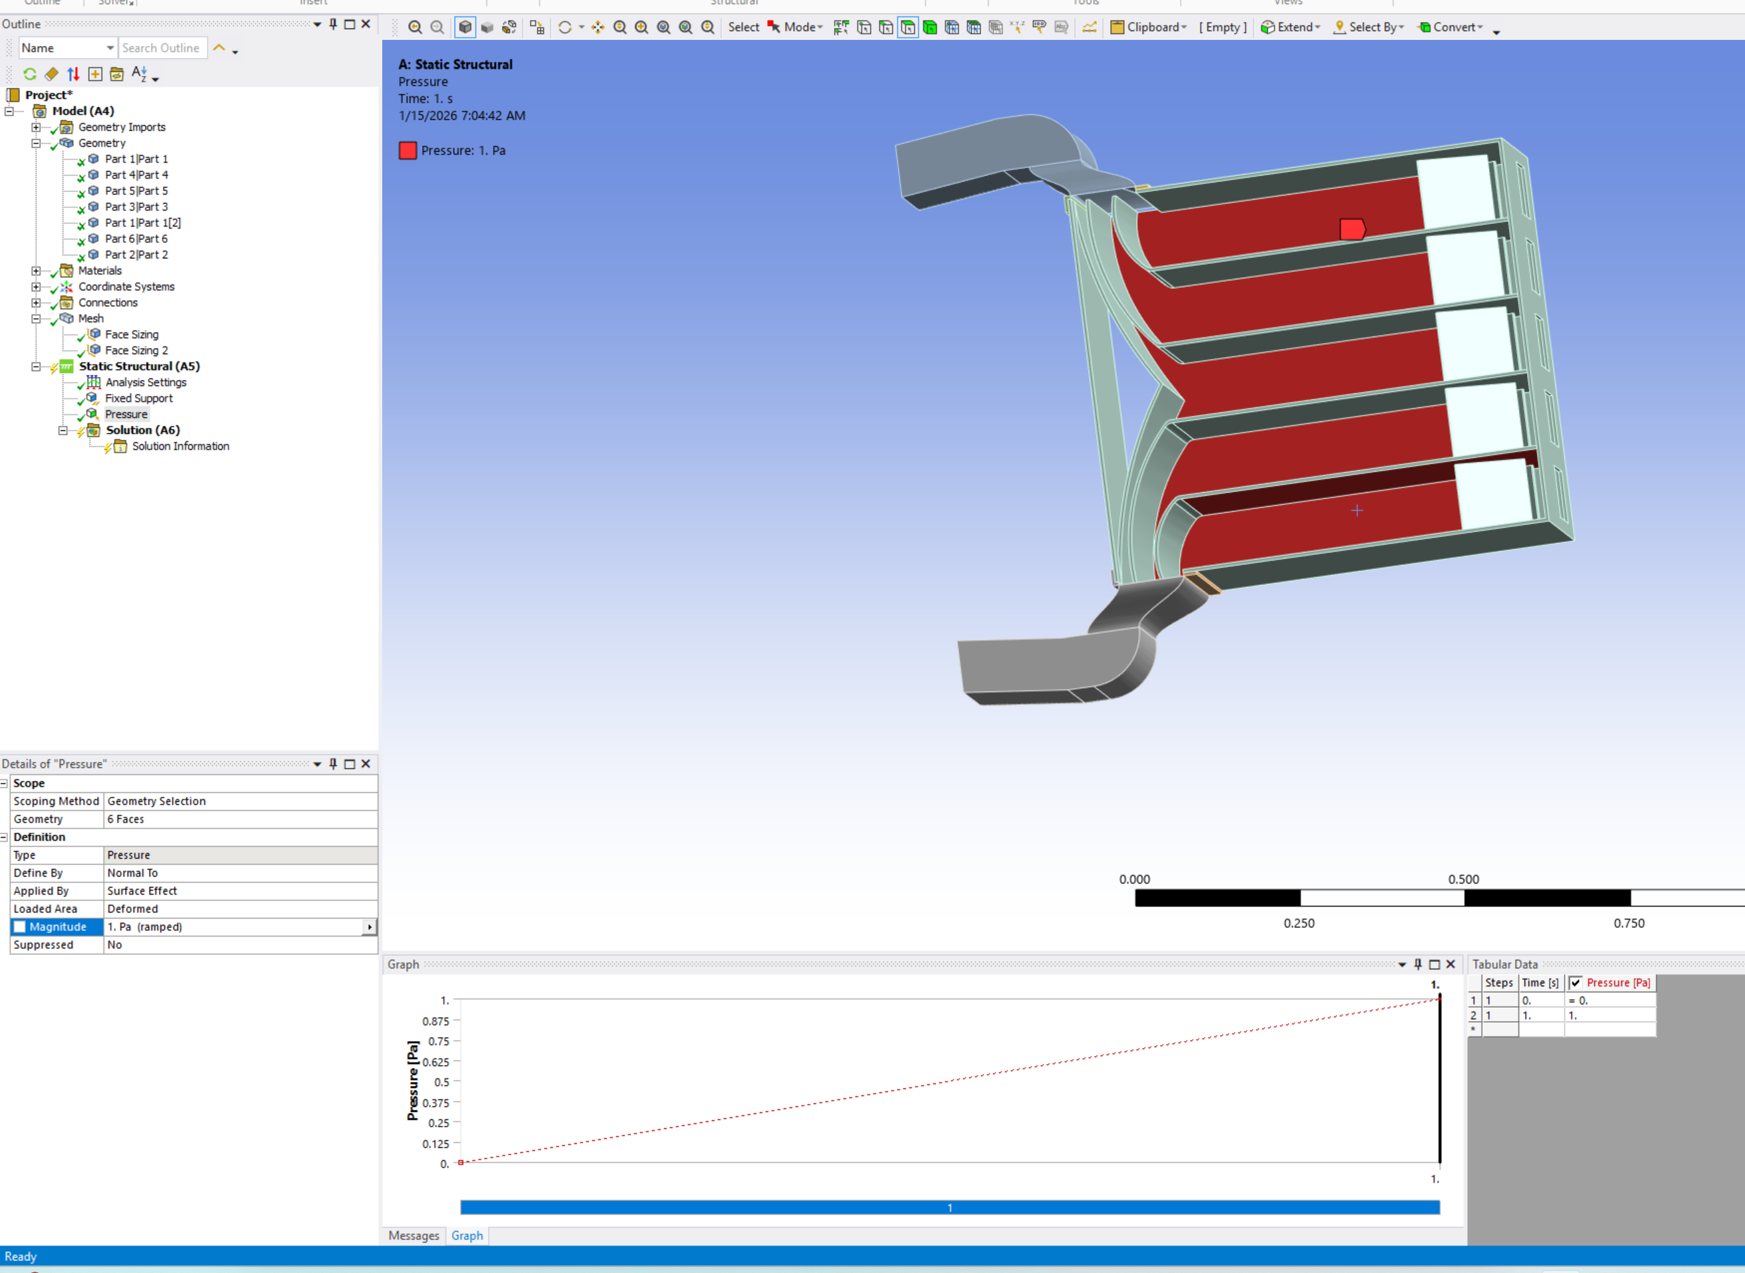Figure 3: the force I apply one the bottom surface

I change the geometry since I have an issues working one the last one due to the complexity of the shape.

New simulation

* Look at the size of the node and the element we have 17121 for the nodes and 8119 for the elements by default of meshing
* 1 pascal one the bottom surface for the pressure apply
* The bottom , the lateral surface so 3 surface are consider to be fixed we then have the result in the sim 1
* I saved the video one simulatio_default_meshing.mp4

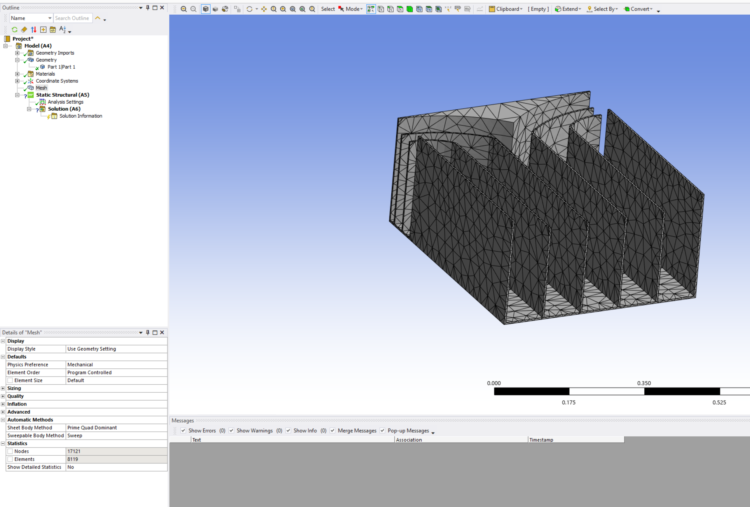Figure 4: numbers of nodes and element for the simulation

* I update the mesh with a new size on the bottom surface for 0.002 to accurate the results

The result of the nodes are 752654 and the elements are 434737

That gives

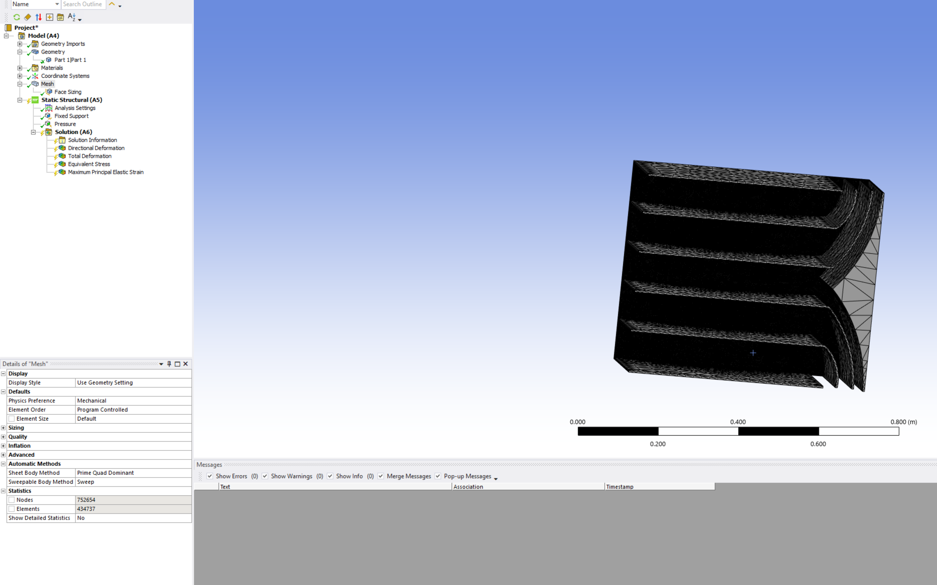Figure 5: the meshing result

* I have an error for the simulation because my license doesn’ t allow me to simulate more than a certain numbers of nodes and elements the proof

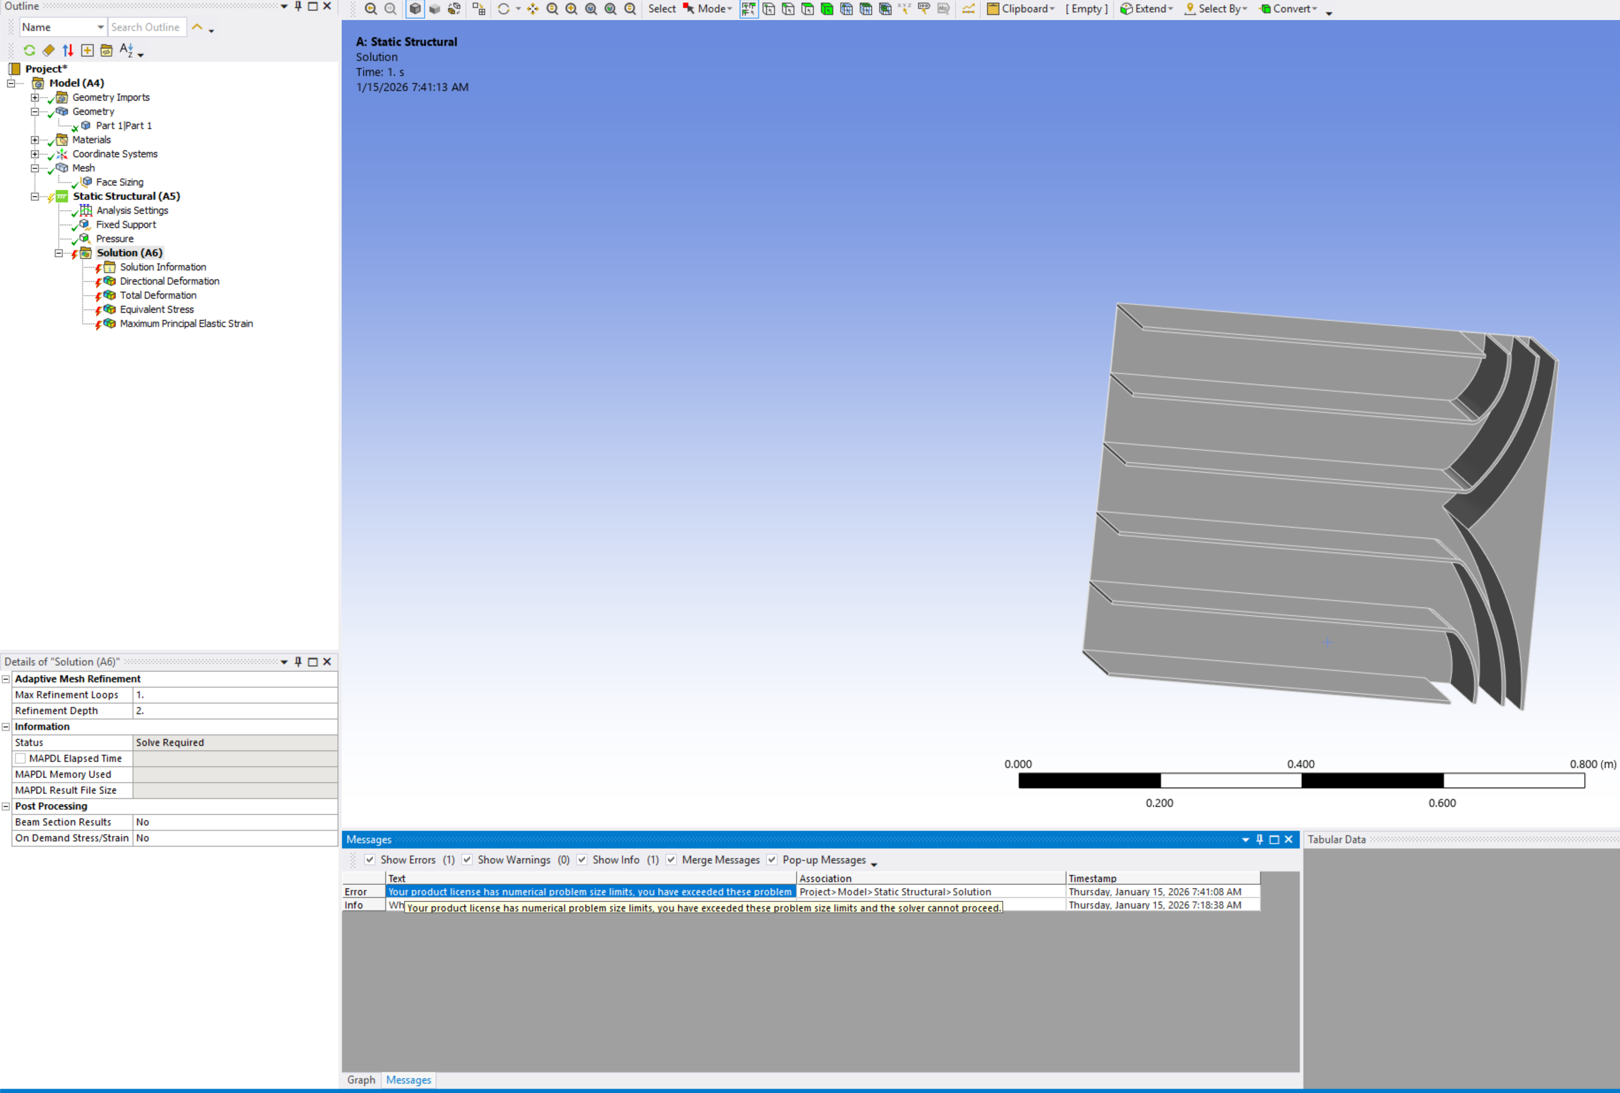Figure 6: proof that i can't simulate that amount of nodes and elements

For the size of 0.01 I have a result for the meshing we have

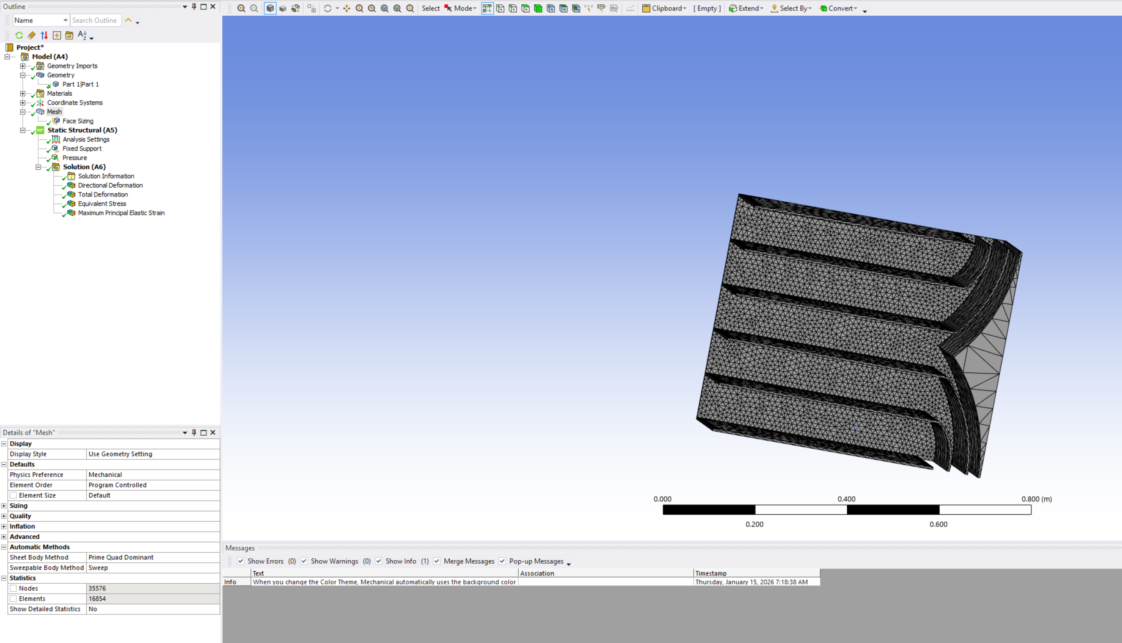Figure 7: new meshing result with 0.01 as size for the bottom surface

* The result now for this is in video simulatio_sizing_0.01_meshing.mp4

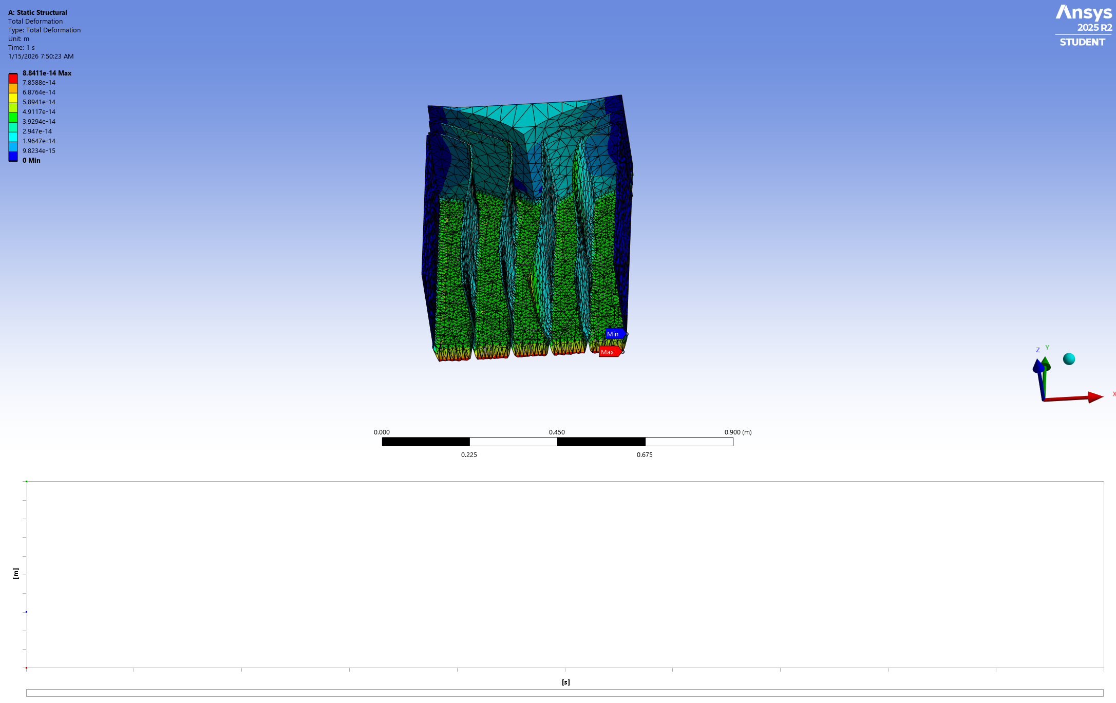Figure 8: Total deformation for size 0.01 at the bottom

The von Mises stress result

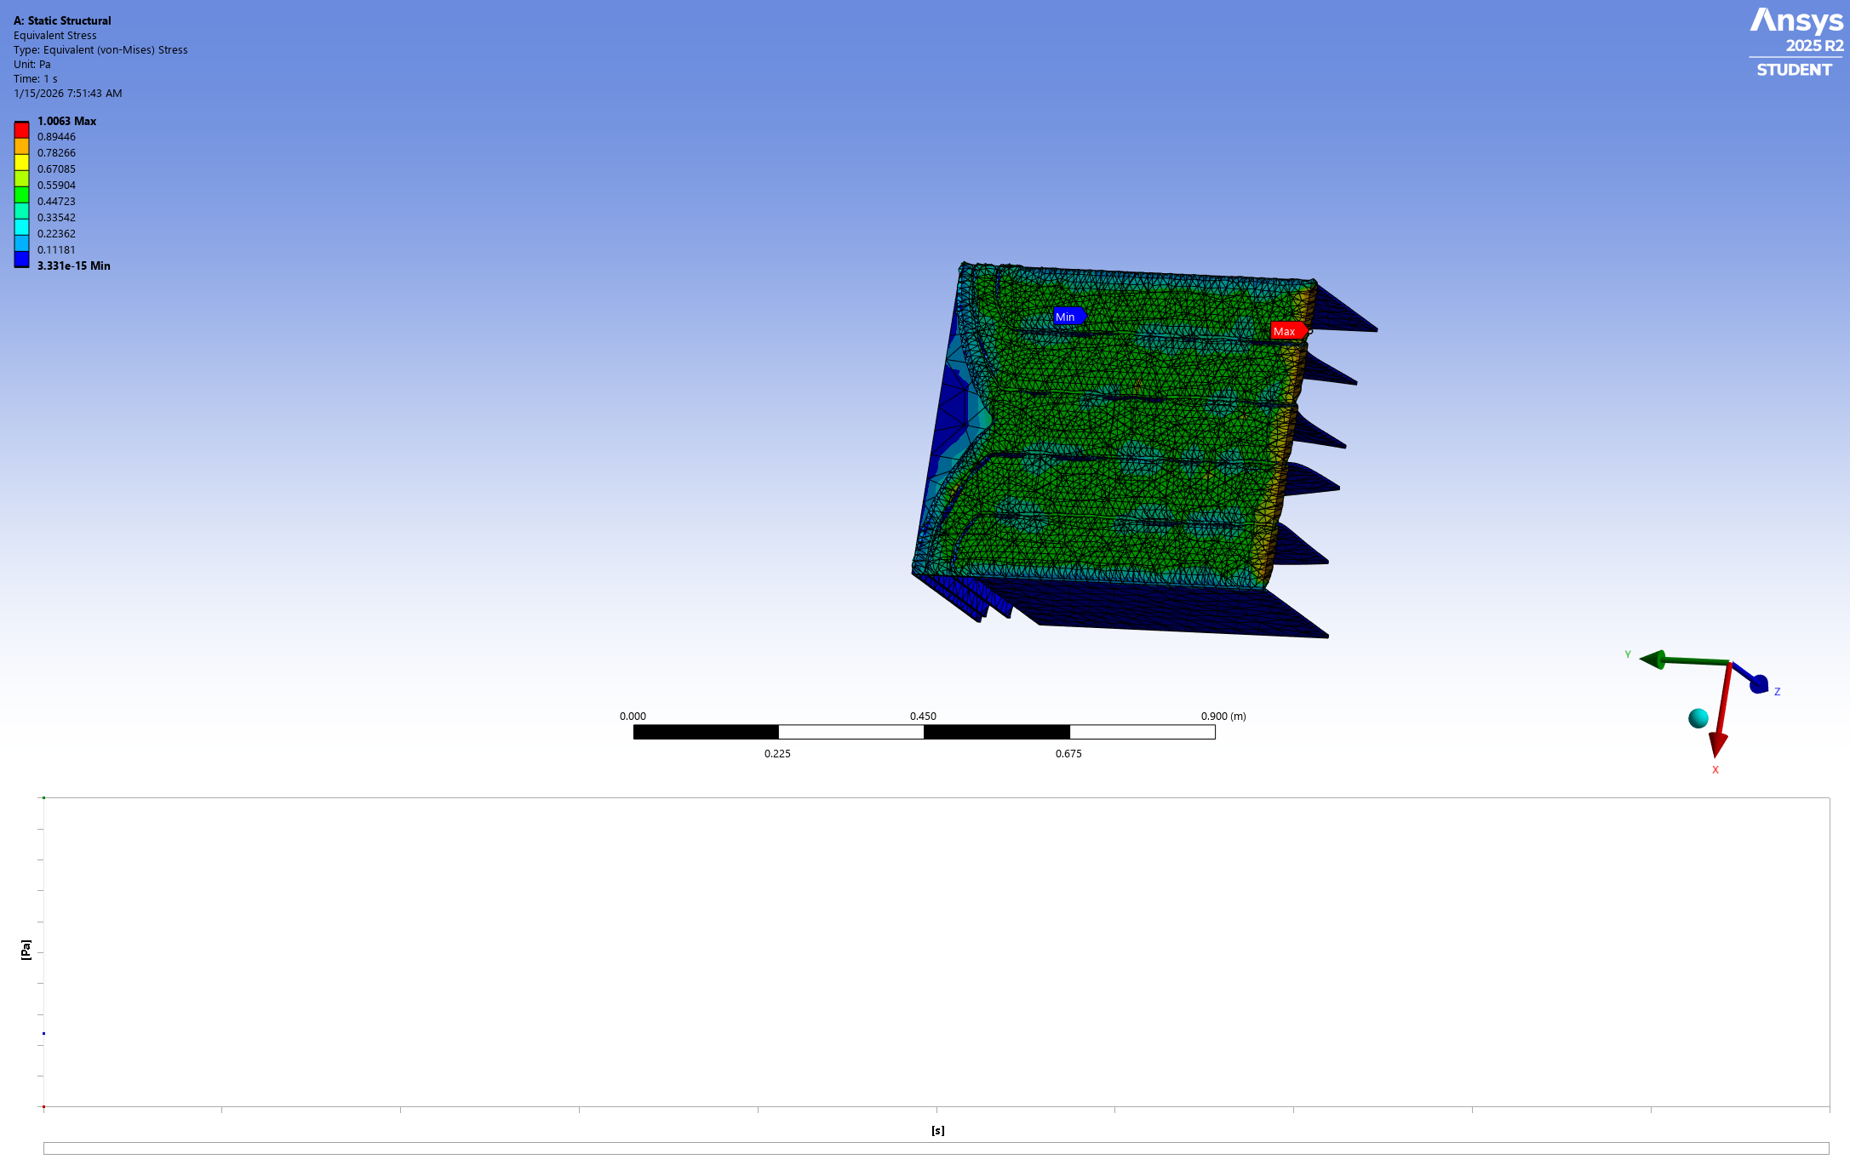Figure 9: von mises stress for size 0.01

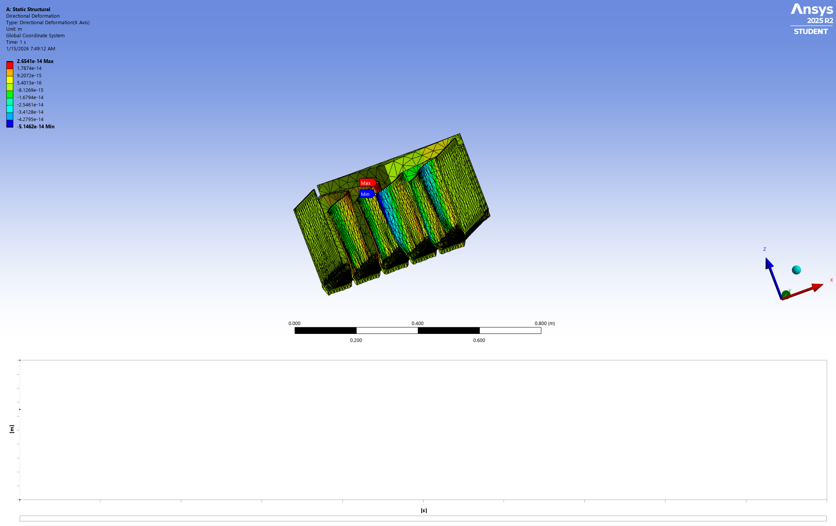Figure 10: Directionnal deformation

SUMMARY

1. **Material and Geometry:** The container is constructed from **aluminum**

I modified the geometry for this simulation to reduce complexity, as the previous design caused issues during the simulation process

You applied a load of **1 Pascal (Pa) to the bottom surface** of the container

he weight data for the cells used to determine loading was sourced from an external file titled

1. **Boundary Conditions:** To simulate how the container is held in place, you applied **fixed supports to three surfaces**: the bottom surface and two lateral surfaces
2. **Meshing Process and Technical Constraints:**

    ◦ **Initial Mesh:** The default mesh resulted in approximately 17,121 nodes and 8,119 elements.

    ◦ **Refinement Attempt:** You attempted a more granular mesh with a sizing of 0.002 on the bottom surface. However, this generated 752,654 nodes and 434,737 elements, which **triggered a license error** because the count exceeded the software's allowable limits

**Final Mesh:** To successfully run the simulation within my license constraints, I used a **mesh sizing of 0.01**, which allowed for a successful result

**A) Geometry**

The initial geometry (with two pipes on each side) presented computational complexity and caused convergence issues during simulation. Therefore, the geometry was simplified to a single-chamber container design to facilitate robust FEA analysis while maintaining representative loading conditions.

**B) Loading and Boundary Conditions**

**Applied Load:**

* A uniform pressure of **1 Pascal (Pa)** is applied to the bottom surface of the container.

**Fixed Supports:**  
To simulate real-world constraints, fixed supports (zero displacement boundary conditions) are applied to **three surfaces**:

* Bottom surface
* Left lateral surface
* Right lateral surface

**C) Meshing Strategy and Technical Constraints**

**Mesh development process**

**Initial Mesh:**

1. Number of nodes: 17,121
2. Number of elements: 8,119
3. Element type: Default ANSYS meshing
4. Assessment: Coarse resolution; provided quick preview of structural behavior

**Refinement Attempt (Bottom Surface Sizing = 0.002 m):**

* Number of nodes: 752,654
* Number of elements: 434,737
* Result: **License error encountered** — the software license restricts analysis to a maximum of ~100,000 nodes and elements
* Status: Simulation could not be executed due to license limitations

**Final Mesh (Bottom Surface Sizing = 0.01 m):**

* Number of nodes: Within license limits
* Number of elements: Within license limits
* Status: **Successful execution**
* Animation saved: *simulation_sizing_0.01_meshing.mp4*

This mesh sizing represents a compromise between solution accuracy and computational constraints, while remaining within the software license restrictions.

**D) Total deformation**

The total deformation plot shows the magnitude of displacement across the container structure under 1 Pa pressure loading. Maximum deformation occurs at regions of lowest constraint stiffness.

The von Mises equivalent stress reveals the stress concentration patterns throughout the container. This criterion indicates regions approaching material yield strength (2.8 × 10⁸ Pa for aluminum alloy).